Exercise 1 – Basic Spring Application

Name: Shubham Sangram Bej

Aim
To develop a basic Spring application using XML-based configuration and demonstrate the creation and management of Spring beans through the Spring IoC (Inversion of Control) container.

Objective
- To understand the basics of the Spring Framework.
- To configure beans using an XML configuration file.
- To load the Spring ApplicationContext.
- To retrieve and execute Spring-managed beans.

Software Requirements
- Java JDK 21
- IntelliJ IDEA
- Apache Maven
- Spring Framework 5.x

Theory
The Spring Framework is a lightweight framework used for developing enterprise Java applications. One of its core features is the IoC (Inversion of Control) container, which manages the lifecycle of objects called beans. Instead of manually creating objects, Spring instantiates and configures them based on XML or annotation-based configuration. This approach promotes loose coupling and improves maintainability.

Project Components

BookRepository
Handles the repository layer responsible for retrieving book information.

BookService
Represents the service layer that performs business operations related to books.

applicationContext.xml
Defines the Spring beans and allows the IoC container to manage them.

LibraryApplication
Loads the Spring container, retrieves the configured beans, and executes the application.

Procedure
- Created a Maven project in IntelliJ IDEA.
- Added the Spring Context dependency in pom.xml.
- Created the BookRepository and BookService classes.
- Configured beans in applicationContext.xml.
- Loaded the Spring IoC container using ClassPathXmlApplicationContext.
- Retrieved the beans from the container.
- Executed the application and verified the output.

Output

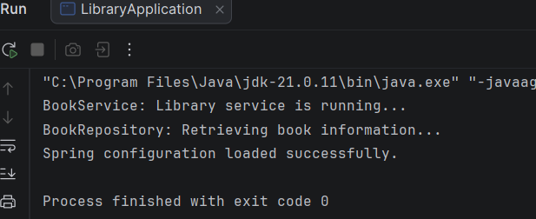

Screenshots
- Project Structure
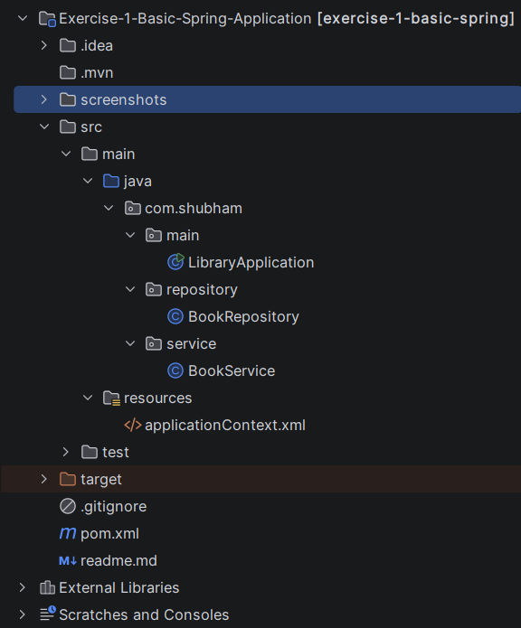
- pom.xml
<?xml version="1.0" encoding="UTF-8"?>
<project xmlns="http://maven.apache.org/POM/4.0.0"
xmlns:xsi="http://www.w3.org/2001/XMLSchema-instance"
xsi:schemaLocation="http://maven.apache.org/POM/4.0.0
http://maven.apache.org/xsd/maven-4.0.0.xsd">
<modelVersion>4.0.0</modelVersion>
<groupId>com.shubham</groupId>
<artifactId>exercise-1-basic-spring</artifactId>
<version>1.0-SNAPSHOT</version>
<properties>
<maven.compiler.source>21</maven.compiler.source>
<maven.compiler.target>21</maven.compiler.target>
<project.build.sourceEncoding>UTF-8</project.build.sourceEncoding>
<spring.version>5.3.39</spring.version>
</properties>
<dependencies>
<dependency>
<groupId>org.springframework</groupId>
<artifactId>spring-context</artifactId>
<version>${spring.version}</version>
</dependency>
</dependencies>
</project>

- applicationContext.xml
<?xml version="1.0" encoding="UTF-8"?>
<beans xmlns="http://www.springframework.org/schema/beans"
xmlns:xsi="http://www.w3.org/2001/XMLSchema-instance"
xsi:schemaLocation="
http://www.springframework.org/schema/beans
https://www.springframework.org/schema/beans/spring-beans.xsd">
<bean id="bookRepository"
class="com.shubham.repository.BookRepository"/>
<bean id="bookService"
class="com.shubham.service.BookService"/>
</beans>

- Java Source Code
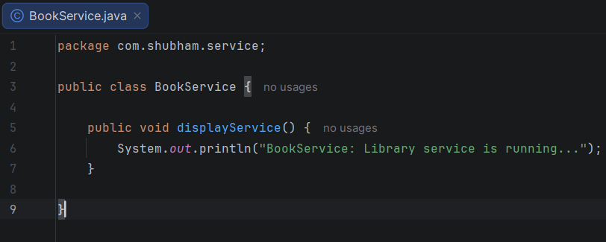
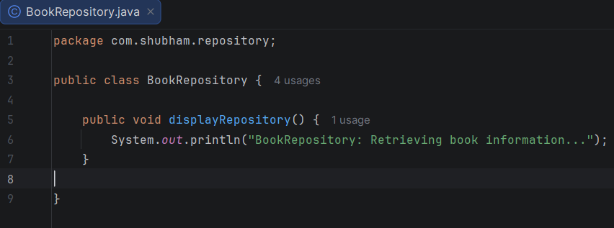

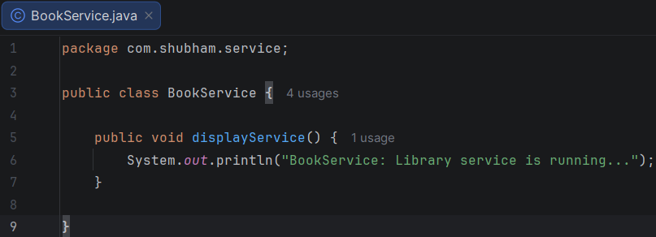

Result
The Spring application was successfully developed and executed. The Spring IoC container correctly instantiated and managed the configured beans, demonstrating the fundamentals of XML-based bean configuration.

Conclusion
This experiment provided practical exposure to the Spring Framework and its IoC container. XML-based bean configuration was successfully implemented, and the application executed correctly, demonstrating the basic concepts of Spring bean management.

